
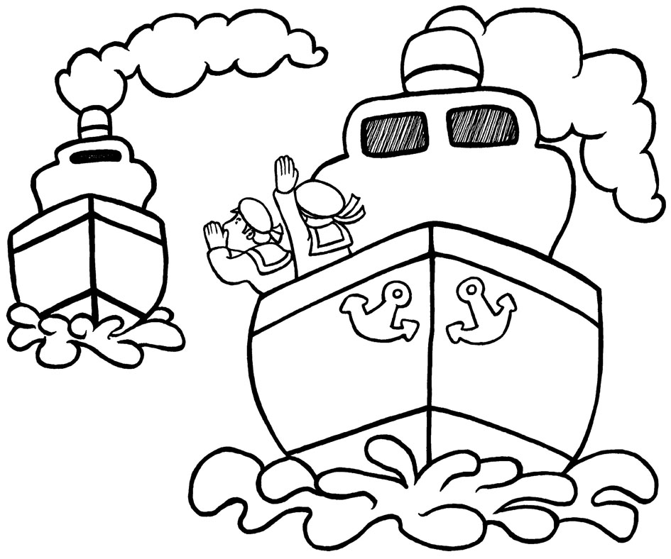
Name: Date:
‘oi’ Missing Word Sentecnes

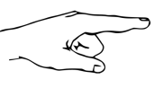
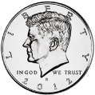
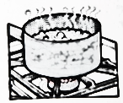
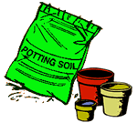
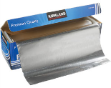
coin point oil
foil soil boil

1) On Monday my dad gave me a £1 _________.
2) I put three seeds into the _________.
3) If you want to cook noodles you have to _________ water.
4) If your car is too hot you should put new _________ in it.
5) Do not _________ at the King, it is bad to do.
6) Put the meat in the _________ to cook it.

