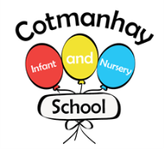

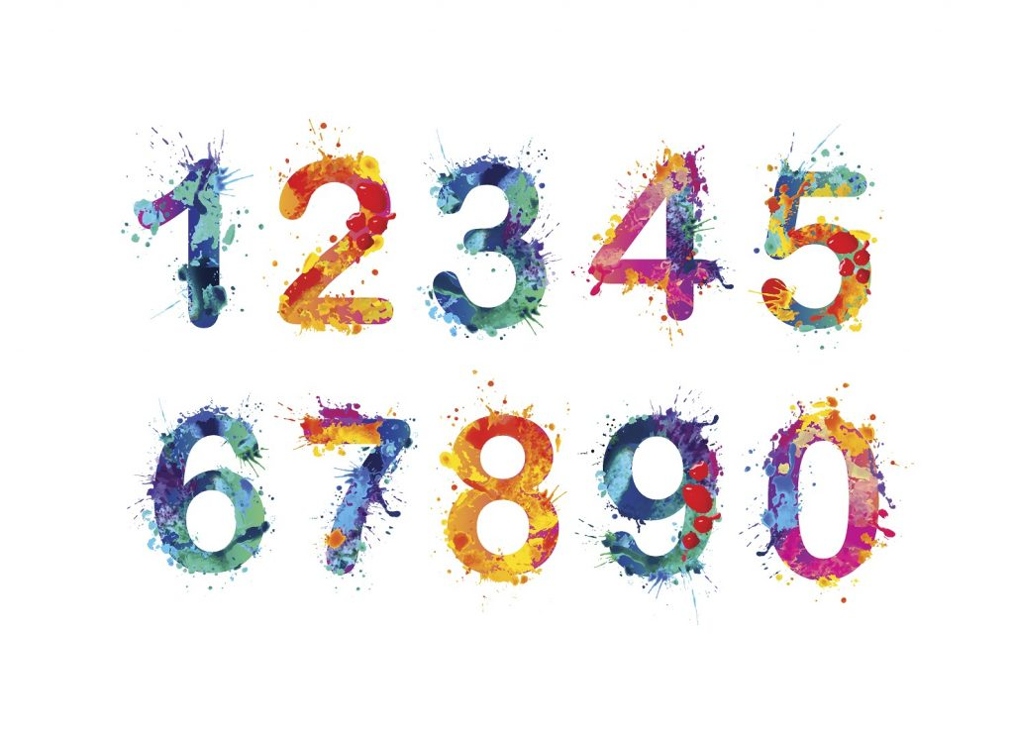

**Maths targets** Please encourage your child to:

* To count to 20 and beyond.
* To recognise numbers to 10 then 20 and beyond .

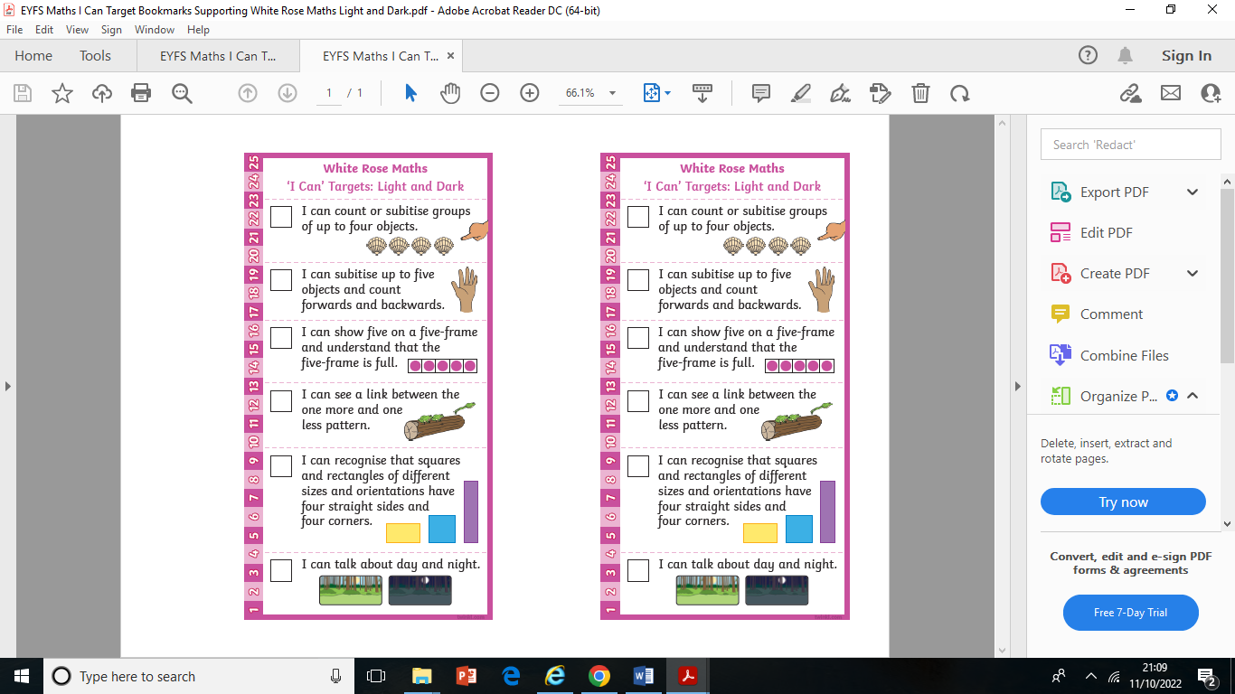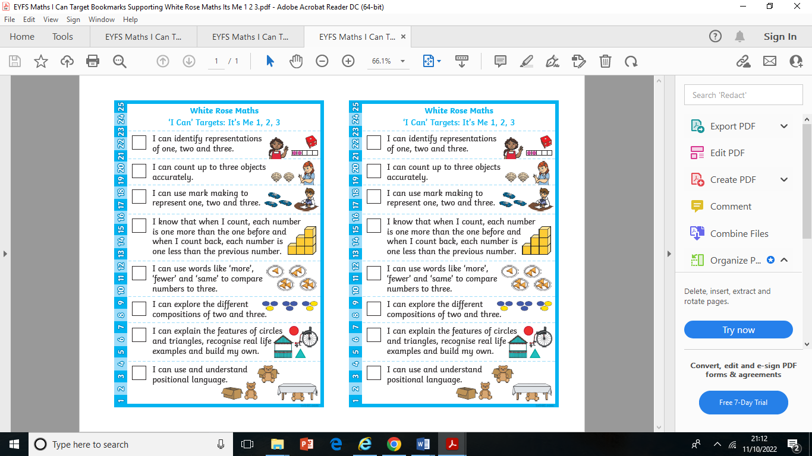

Numberblocks is great to watch:

<https://www.bbc.co.uk/iplayer/search?q=numberblocks>

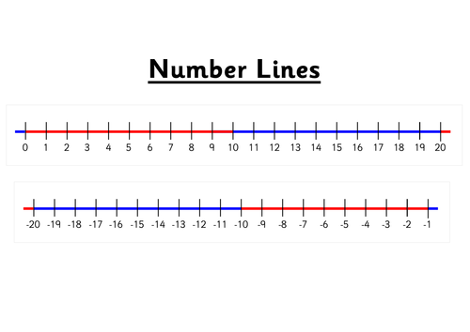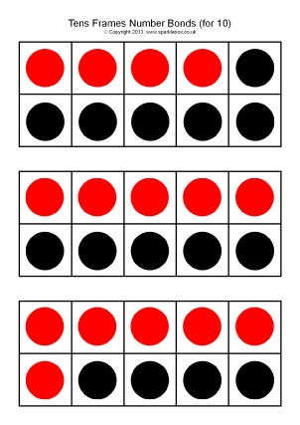

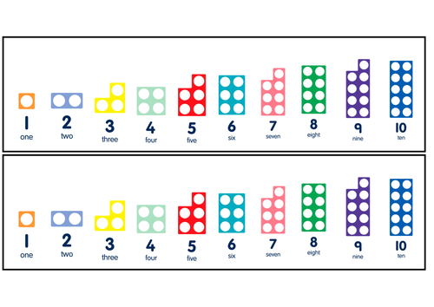



**Communication, Language and Literacy targets:**

Please encourage your child to;

* To write their own name independently and begin to form all letters correctly.

Write all the letter sounds they can hear in their writing. Complete the homework sheets linked to the phonemes they’re learning.

To hold a book confidently, to point to each word as they read it and use picture clues to read a story.

* Practise their letter sounds and words on their reading cards in their book bags every night. Go to this link to see how we produce these sounds:

<https://www.littlewandlelettersandsounds.org.uk/resources/for-parents/>

To begin to retell the main events in a familiar story in the right order and talk about the main characters and begin to make up a different ending.

* To talk clearly in full sentences and learn and understand the meanings of the words linked to our topic.

**Autumn 2**

**October-December**

**Our Topic**

## **Dark Woods**

**Books we will share**: Winnie the Witch

Room on the Broom

Jolly Postman, Christmas

Christmas story

Bonfire Night





**Key Vocabulary:**

**Please encourage your child to learn, understand and use these terms and words. ‘Whisper the word, say the word, act the word and say it in a sentence’** [**https://www.youtube.com/watch?v=428l9PIED_I**](https://www.youtube.com/watch?v=428l9PIED_I)

Healthy, unhealthy, different Seasons, Autumn, Change, Runny, similar, wobbly, shape, Nativity, celebration, hear, smell, see, touch, taste, nocturnal, owl, badger. Liquid, solid, melt, subitise, represent, enchanted, mysterious, transform, creak, disappeared, bubbly, cackled.

caring

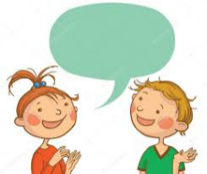



**OUR TOPIC FOCUS THIS TERM:** Please help your child by helping them to talk about and gain experiences linked to the following:

* To talk about what they’re good at and know that we celebrate our differences and knowing we’re all special.
* To name our senses, hear, see, smell, touch and taste. To explore our natural world and look for shapes in the environment. To explore simple changes such as melting. To identify and name nocturnal animals.
* To know why Christians celebrate Christmas.
* Know how to care for our environment and make maps of our local area.
* Know how to stay safe on line.
* Be able to creatively record their experiences and ideas and talk about their work, saying what they’ve used and why. (Designing and making puppets linked to our stories, making Christmas cards and calendars).
* Be able to talk about how things have changed over time, comparing the Christmas story to present day.

**Some lovely enrichment activities we will be doing this term:**

**Walking to the post office to post our letter to Santa**

**Making jelly**

**Exploring the forest schools area**

Please look on our school website for lots of games and resources in our EYFS section: <https://www.cotmanhayinfants.co.uk/page/?title=Reception&pid=125>

Snack Contribution

**We welcome a contribution of 50p each week.**

This helps towards the cost of your child’s daily healthy snack, play dough and malleable materials, baking and cooking activities and the lovely resources we need to ensure the children have access to a wide range of fun and exciting learning opportunities.

**We really do value your 50p contribution**.

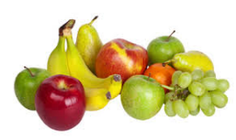

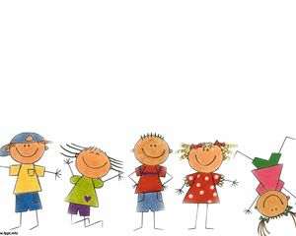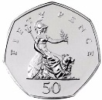



Dates for your Diaries

**School returns: Monday 3rd November (We’ll send more information about these dates nearer the time on DoJo)**

**Week beginning November 10th – Anti Bullying Week/ Odd Socks Day.**

**Friday 14th November –** Children in Need Day- Non-uniform day £1 donation please.

**Wednesday 19th and Thursday 20th November** - Parents Evening Consultations.

**Wednesday 26th November** – weather permitting, we’ll walk to the post office to send our letters to Santa – children to wear warm, appropriate clothing please.

**Wednesday 10th December - Christmas Dinner in school**

**Thursday 11th December** – Parents invited -2.40pm in the school hall – Reception Christmas Songs

**Tuesday 16th December** – Christmas jumper day

**Wednesday 17th December** – Christmas Party day – children to wear party clothes to school

**Thursday 18th December – last day of term.**

**SCHOOL RE OPENS Monday January 5th.**



+

General Reminders

*Please remember to name all of your child’s belongings including their jumpers, cardigans, coats and hats.

* Please ensure your child has a warm coat every day and hats, gloves, vests, tights and scarves if required.

* Please remember to bring your child’s book bag everyday and practice their words and phonemes written on their cards. *Please continue to bring your child to school on time and aim for 96% attendance.