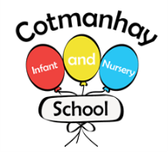

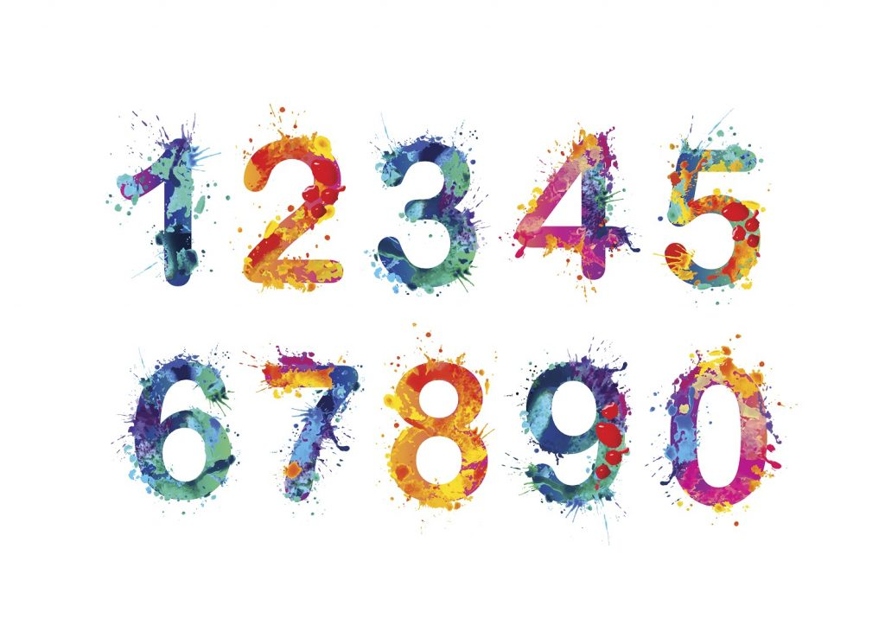

**Maths**

Please encourage your child to:

* To count to 20 forwards and backwards.

* To recognise numbers to 20 and beyond.

* Identify and represent numbers using objects and pictorial representations to 5/10.

* To understand the part whole model. (The whole is the biggest number) the link below is good to watch:

* To identify and use number bonds facts within 10.

* To understand + and = signs and use them to write number sentences.



**English:**

Please encourage your child to;

* To write simple sentences using phonics known independently with letters accurately formed.

* To know the letters of the alphabet and SAY digraphs (sh, ch, th, ai…).

*To point to words and use phonics to read a story.

* To begin to learn the main events in stories and talk about the main characters.

* Please encourage your child to talk clearly in full sentences.

**Autumn 1**

**Year One**

**September - October**

**Our Topic**

**Farms**

We will be learning all about Farms and what they were like in the past.

* **Geography- we will be looking at maps and where we are on the map of the UK**
* **History- We will be learning what a timeline is and about farming in the past**



**RE** – We will be learning all about who is a Christian and what they believe.

**Science** – We will be learning about the human body and seasonal changes in Autumn.

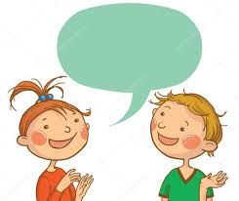

**Key Vocabulary:**

**Please encourage your child to learn, understand and use these terms and words. ‘Whisper the word, say the word, act the word and say it in a sentence’**

Farm, tractor, map, scarecrow, crops, arable, dairy, wheat, plough, sheep, hen, senses, scent, sniff, stench, smell, nose, soft, hard, smooth, rough, skin, savoury, bitter, sour, salty, sweet, noisy, load, quiet, hear, ear, blind, dark, light, eye, human body, elbow, mouth, head.





General Reminders

**PLEASE REMEMBER:**

* To contact us by dojo if you have any concerns or questions.

* To **name all of your child’s belongings** including their jumpers, cardigans, coats and hats.

* To be aware that outdoor play is a very important part of the curriculum, and we aim to go outside every day so it is important to bring a coat every day.

**How can you help your child:**

* Please hear your child read **everyday!**

**\* Bring your reading bag everyday we read when we can.**

* To help your child to write at home their spellings each week.

* To complete maths seeds homework set each week. This is set on a Monday each week.

* Please encourage children to get dressed on their own daily.

Make sure children are wearing their PE kits on PE days and earings removed or taped (Your class teacher will put days on dojo)



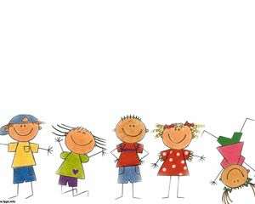

Dates for your Diaries

* Wednesday 15th October- Harvest Festival
* Friday 24th October – Last day of term.
* Monday 3rd November – Children return to Nursery and School.