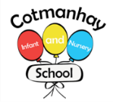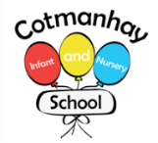

**Mathematics:**

We are learning about:

* To count using efficient methods
* To read, order and write numbers and number words to 20 and beyond.
* Count on in 2s, 10s and 5s.
* To partition whole 2-digit numbers into 10’s and 1’s parts
* To add by drawing, using apparatus, number lines and adding 1 or 2 or 10 mentally.
* To subtract by drawing, using apparatus, number lines and taking 1 or 2 or 10 mentally.
* To solve simple number problems in everyday contexts.
* To compare numbers using greater than, less than and equal to symbols.



**English:**

We are learning:

* To read and spell more words correctly.
* To read a variety of stories, poems and information about seasons, the UK, continents and oceans and Robinson Crusoe.
* To use full stops, finger spaces and capital letters, especially for proper nouns.
* To use adjectives and noun phrases in poetry and descriptions
* To use statements, questions, exclamations and command sentences and use ? ! correctly.

**Autumn Term**

**September– Oct**

**Tawny Owls & Tigers**



**Our Topic:** .**Survival**

**(Geography and History)**

We will be learning about how to survive and stay healthy in different places:

* **Geography** – Where in the world is the UK? What are the different parts of the UK? What are desert islands and where in the world are they?

To understand and use geographical terms for features of a desert island for example ‘valley’.

* **History** – Who were Daniel Defoe, Alexander Selkirk and the Robertson family?
* **RE** Who is Jewish and what do they believe?





* **Science** – Find out what animals need to survive. (food, water and air)
* Learn about different animal groups; mammals, amphibians, reptiles, birds and fish.
* Learn about the importance of a healthy diet, exercise and good hygiene.

**Key Vocabulary:**

**Please encourage your child to learn, understand and use these terms and words. ‘Whisper the word, say the word, act the word and say it in a sentence’**

**Linked to Robinson Crusoe and history:** Adventure, deserted, survive, past, present, rescue, explore, discovered, ship, shelter. Daniel Dafoe, Alexander Selkirk, the Robertson family

**Linked to geography:** sea, ocean, home, island, mountain, valley, continent, stream, beach, camp, map, lake, river, globe, coast, forest.

**For science and maths vocabulary – see separate sheet.**

**How can you help your child:**

* Please read with your child every day, it doesn’t have to be for long, 10 minutes a day can be enough.

Ask your child to read their book to you as often as possible – just a few pages at a time. Little and often is best!

* Please help your child with their maths homework. This is sent home at the end of a block of teaching and will include some problem solving and reasoning which will encourage your child to use the maths words they know.

* Please encourage your child to talk about what they have learnt at school by asking them questions about it.

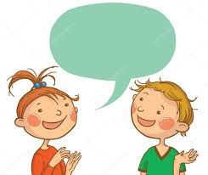



**General Reminders**

* Please remember to name all of your child’s belongings including their jumpers, cardigans, coats and hats.
* Please make sure your child wears their PE clothes on their class PE day and all jewellery is removed.
* Please make sure that your child brings their book bag to school every day

***Many thanks***

