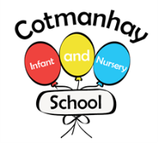

**Spring Term 3**

**Tawny Owls, Wallabies and Tigers**

**Our Topic**

India:

* Find out about our world, the continents, oceans and countries.
* Locate Europe, UK, Asia and India on a world map.
* Learn about the people and places in the UK and India.
* Look at Indian art and make some of our own.
* Learn about British Values and our role in modern Britain, appreciating similarities and differences between us and others.
* Learn a traditional Indian dance
* Prepare and taste some Indian food.
* Find out how best to insulate an ice cube.
* Learn about the life of Gandhi.

**SCIENCE:**

* Learning about what plants need to grow
* Investigating the effects of light and dark on plants.
* Living things and their habitats.

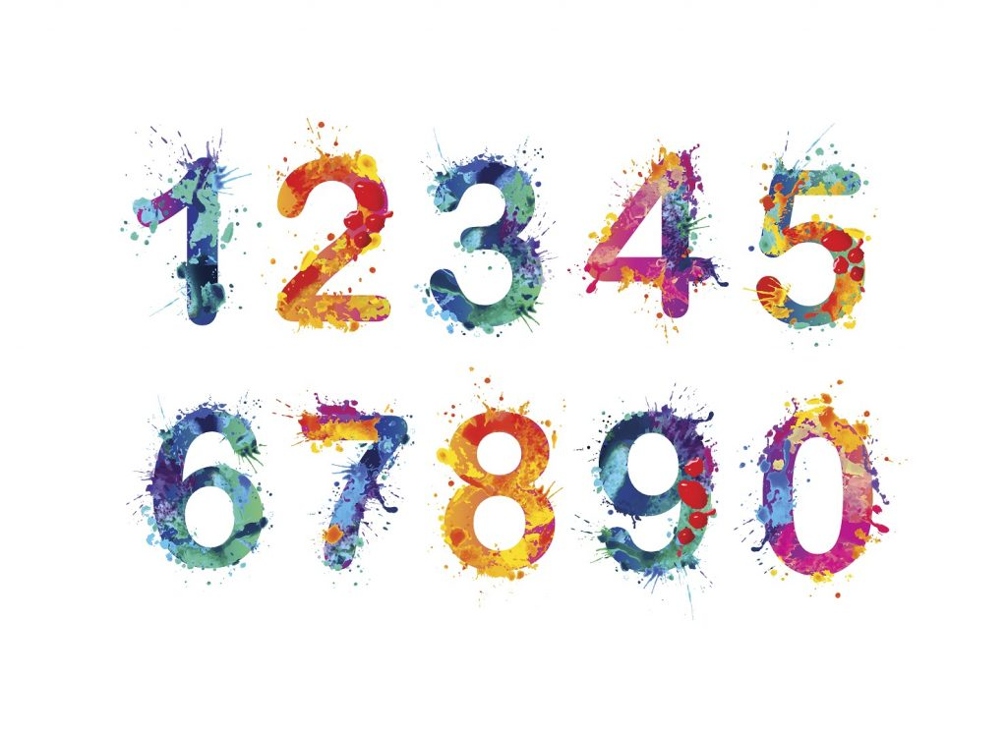

**Mathematics:**

We are learning

* To understand multiplication as equal groups
* To know how to use arrays and repeated addition.
* To learn about doubles and the 2 times-table.
* To learn about the 5 and 10s times-table.
* To understand division as sharing and grouping.
* To recognise and use pounds and pence
* To combine amounts of money
* To solve simple money problems using addition and subtraction



**English:**

We are learning

* To read and spell more words correctly.
* To read a variety of stories, poems and information about India including traditional tales from other cultures and seasonal poems.
* To use capital letters for proper nouns, full stops, commas, exclamation marks, question marks and apostrophes.
* To use adjectives, adverbs, alliteration, plurals and noun phrases in our writing.
* To learn about different types of sentences: commands, questions, statements and exclamation sentences.
* To use the past and present tense correctly including irregular past tense verbs – eg; I am swimming (present tense) and yesterday I swam (past tense)



**Key Vocabulary: Please encourage your child to learn, understand and use these terms and words. ‘Whisper the word, say the word, act the word and say it in a sentence’**

**Linked to India:** mandir, Gandhi, Taj Mahal, Hinduism, Rangoli, Mehndi, Asia

**Linked to science: predict, measure, explain, materials, investigate, insulate, temperature, freezing point, boiling point, degrees Centigrade. See separate sheet for additional science vocabulary.**

**Linked to geography:** continent, ocean, Asia, Europe, equator, seasons, Spring, Summer, Autumn, Winter, monsoon, United Kingdom, Himalayas, Ganges, feature, city, town, village, coast, transport, journey

**Linked to history:** The Taj Mahal, Shah Jahan, Mumtaz Mahal, Gandhi

**Linked to Mathematics:** Money, £ pound and p pence, equal groups, unequal groups, lots of, repeated addition ,doubles, arrays, rows, columns, multiplication, symbol x, multiply, multiplied by, commutativity, count in 2s, 5s, 10s, times-table, sharing equally, grouping, division, divide symbol ÷, odd, even.

**How can you help your child:**

* Please hear your child read every day, it doesn’t have to be for long, 5-10 minutes a day can be enough. You could encourage your child to find tricky words in their bedtime story book as well.

* Please help your child with their maths homework. This is sent home at the end of a block of teaching and will include some problem solving and reasoning which will encourage your child to use the maths words they know. Don’t forget to log on to Mathseeds at home.

* Please encourage your child to talk about what they have been learning about at school and encourage them to find out more about India at home.

* Please check our Class Dojo pages regularly for updates and activities.

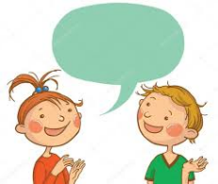



General Reminders

*Please remember to name all of your child’s belongings including their jumpers, cardigans, coats and hats.

* Please make sure your child wears their PE kit on the correct days.

* Please remember to bring your child’s book bag to school every day.

*Please remember to arrive at school on time.

**Thank you for your continued support ☺**

