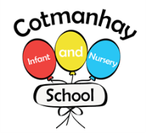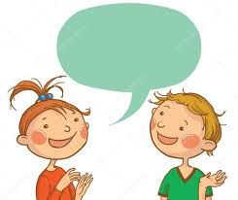



**Communication, Language and Literacy targets:**

Please encourage your child to;

* To write their own name independently with letters accurately formed.

* To know the letters of the alphabet and which sound they make. WE USE A PHONICS SCHEME CALLED ‘Little Wandle’. Please go to the school website to view the new scheme and watch the video to see how to say the letter sounds: <https://www.littlewandlelettersandsounds.org.uk/resources/for-parents/>

To hold a book confidently, to point to words and use picture clues to read a story.

* To begin to learn the main events in stories and talk about the main characters.

* To begin to read small words like – sat man hug red peck and the ‘tricky’ words ‘I is the’.

* To talk clearly in full sentences and be able to say what they have learnt.

**Autumn 1**

**September - October**

**Maths targets** Please encourage your child to:

Series 1 episodes 1-5 are great to watch on Numberblocks: <https://www.bbc.co.uk/iplayer/search?q=numberblocks>



**Our Topic:**

## **Traditional Tales**

**Goldilocks and the Three Bears**

**Little Red Riding Hood**

**Gingerbread Man**

**Three Little Pigs**

**Three Billy Goats Gruff**

**Jack and the Beanstalk**

**Little Red Hen**

**Key Vocabulary:**

**Please encourage your child to learn, understand and use these terms and words:**

**Same different changed grown more less fewer soft hard strong hard smooth bumpy animal farm horse body mouth teeth field sty barn stable coop**



Snack Contribution

**Please remember to pay your child’s snack contribution of 50p each week.**

This helps towards the cost of your child’s daily healthy snack, play dough and malleable materials, baking and cooking activities and the lovely resources we need to ensure the children have access to a wide range of fun and exciting learning opportunities.

**We really do value your 50p contribution**.

**OUR TOPIC FOCUS THIS TERM:**

Please help your child by helping them to talk about and gain experiences linked to the following:

* Talking about how they’ve changed over time and talk about what they can do now that they couldn’t do as a baby.
* Be able to sort healthy and unhealthy food and know why making healthy choices are important and why it’s important to brush our teeth.
* To sort, match and name basic farm animals and objects.
* To talk about what makes us special and how different religions welcome babies into the world.
* To talk about their feelings in their new class, learn the school rules and know their responsibilities.
* Know how to care for our environment and recycle materials.
* Know how to stay safe on line.
* Be able to creatively record their experiences and ideas and talk about their work, saying what they’ve used and why. (We’ll be drawing observational pictures of themselves, making puppets and mixing paints to create pictures of the characters from stories and farm animals)

**Some lovely enrichment activities we will be doing this term:**

**Baking activities linked to the story of the week:**

**Making porridge**

**Decorating Gingerbread biscuits.**

**Planting bean plants.**

Please look on our school website for lots of games and resources in our EYFS section:<https://www.cotmanhayinfants.co.uk/our-eyfs/>



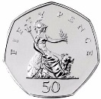

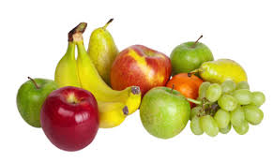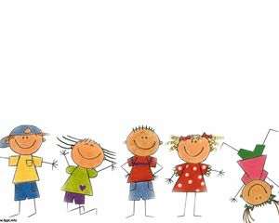

Dates for your Diaries

INSET DAYS-School closed but a good time to call us if you have any questions on 01159302064 – Thursday 4th and Friday 5th September

The first 3 days children attend mornings only on Monday 8th, Tuesday 9th Wednesday 10th:

Raccoons Class (Mrs Holmes):The first 3 days – 8.45-12.10pm –bring and collect from the front playground

Whales Class (Mrs Gillott) :The first 3 days – 8.45-12.15pm –bring and collect from the front playground

Robins class (Miss Foster): The first 3 days – 8.45-12pm –bring and collect from the front playground

From Thursday 11th Sept –YOUR CHILD STARTS FULL TIME AND WILL CONTINUE TO ATTEND ALL DAY FROM NOW ON. Your class teacher will remind you of the times.

Fun Harvest day in school – Wednesday October 15th

*Tuesday October 21st – School PHOTOGRAPHER – please ensure your child attends

*Friday 24th October – Last day of term.

*Monday 3rd November – school re opens.



General Reminders

PLEASE REMEMBER:

*Please remember to name all of your child’s belongings including their jumpers, cardigans, coats and hats.

*Please be aware that outdoor play is a very important part of the curriculum, and we aim to go outside every day. Please ensure your child has a warm coat every day and hats, gloves and scarves if required.

* Please remember to bring your child’s book bag everyday and practice their words and phonemes written on their cards. Try to also practice their spellings regularly.