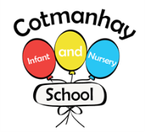

**Autumn Term 2**

**November– December**

**Tawny Owls Wallabies and Tigers**



**English:**

**We will be learning:**

* To read and spell more words correctly.
* To read a variety of stories, poems and information about castles, including stories about Robin Hood.
* To use correct punctuation eg; capital letters for proper nouns, full stops, commas and apostrophes.
* To use adjectives, adverbs, and noun phrases in our writing.
* To use -ed and -ing endings to show past and present tense – eg; walked and walking.

**Our Topic**

## **Castles (History, Geography and Science).**

Where would you like to live? Your house or a castle?

* We will be learning about castles: what they were made of and how they changed over time.
* We will be using and making maps.
* We will learn about castles in different parts of the UK.
* We will discover the roles of the people who lived in castles and different Kings and Queens. We will learn about Robin Hood and the stories about him. Was he real or not?
* We will look at the roles of rich and poor people in castles and how different their lives were.
* We will learn about King Richard I, and King Charles III
* We will learn about Guy Fawkes and The Gunpowder Plot.

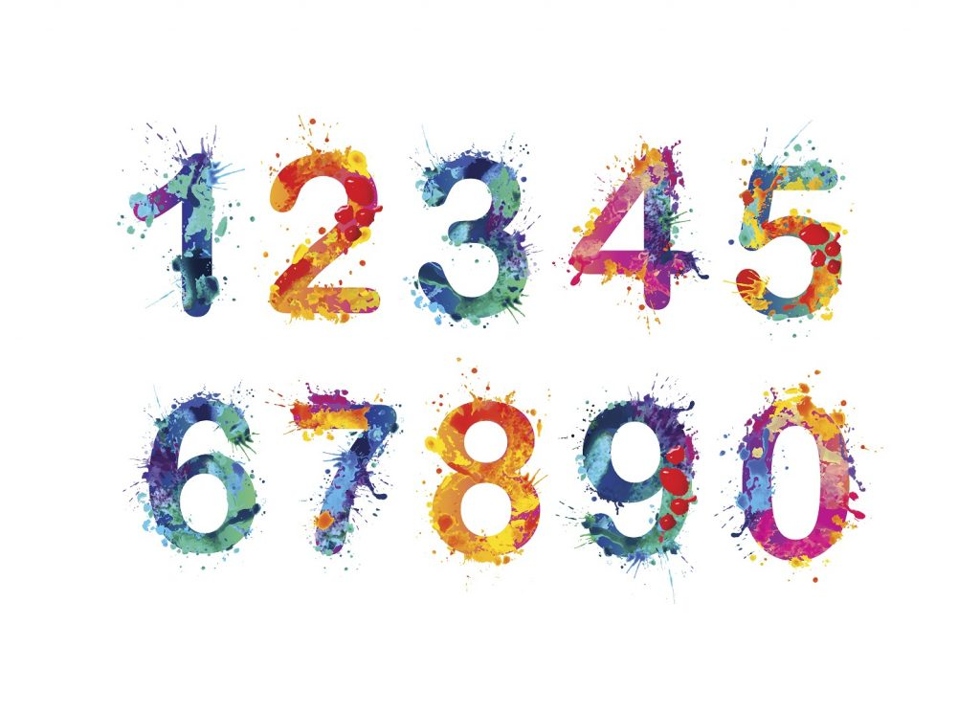

**Mathematics:**

* To add by drawing, using apparatus and number lines and adding 1 or 2 or 10 mentally
* To subtract by drawing, using apparatus and number lines and subtracting 1 or 2 or 10 mentally
* To use number bonds and spot patterns to calculate efficiently.
* To compare number sentences using < > and = symbols.
* To name and describe the features of 2D and 3D shapes.
* Count, read and write numbers to 100 in numerals; count in multiples of 2s, 5s and 10s
* Read and write numbers to at least 100 in numerals and in words
* Recognise the place value of each digit in a 2-digit number (tens, ones)

**How can you help your child:**

* Please read with your child every day, it doesn’t have to be for long; 5-10 minutes a day can be enough. You could read their book to them at bedtime and chat about the story as well as your child reading their book to you.

Please help your child with their phonemes and tricky words – these are always sent home at the start of the week so you know what they are learning in letters and sounds.

* Please help your child with their maths homework. This is sent home at the end of a block of teaching and will include some problem solving and reasoning which will encourage your child to use the maths words they know. Don’t forget to log on to Mathletics and Purple Mash at home.

* Please encourage your child to talk about what they have been learning about at school and encourage them to find out more about castles at home.

* Please check our Class Dojo pages for updates and activities.



**Key Vocabulary: Please encourage your child to learn, understand and use these terms and words. ‘Whisper the word, say the word, act the word and say it in a sentence’**

Linked to Castles and history: Motte and Bailey, Stone Keep, Concentric, battlements, portcullis, arrow slit windows, drawbridge, moat, curtain wall, outer bailey, inner bailey, dungeon, tower, shield, gatehouse, coat of arms, past, present, timeline. Guy Fawkes, gunpowder plot, houses of parliament.

Linked to geography: hill, coast, river, well, UK, England, Scotland, Wales, Northern Ireland, village, town

Linked to Mathematics**:** : Addition, more than, subtract, less than, number bonds, spot patterns, efficient methods, < > = symbols, 2-D shape, circle, square, triangle, rectangle, pentagon, hexagon, octagon, side, vertices, lines of symmetry, 3-D shape, cone, cylinder, cube, cuboid, sphere, pyramid, face, curved surface, edges.

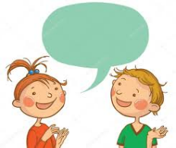

**Dates for your diary**

* Parents evening - 19th and 20th November
* Friday 14th November - School trip to Nottingham Castle
* Wednesday 10th December – Christmas performance to parents.
* Thursday 18th December – Children’s last day
* More dates to follow nearer the time for Christmas party days and activities. Check Dojo regularly – all the information will be on there!



**General Reminders**

**Please read with your child at home as often as possible – they have a reading book linked to their letters and sounds for them to read to you and a ‘Real Book’ for you to share together.**

*Please remember to name all of your child’s belongings including their jumpers, cardigans, coats and hats.

* Please make sure your child has their PE kit on for the class PE days and remove earrings and other jewellery on these days - check Dojo for reminders.

* Please remember to bring your child’s book bag ***every day***.

**Thank you for your continued support ☺**

